## RESEARCH SYSTEMS EXERcise

1

Explain differences between JavaScript Expressions and Angular Expressions?( 3 mins)

e..g. void operator is not allowed in Angular expression, coma is not allowed.

In angular-js the expressions are evaluated against the scope object, while the JS expressions are evaluated against the window object

In angular-js the expression evaluations are forgiving to null and undefnied, where JS undefined properties generates type errors

loops and conditionals cannot be used in angular expressions, where as in JS they are allowed

2

Explain difference between factory and service in AngularJS? (2 mins)

With angular services, an instance is created with the new keyword and the instance gets injected by angularjs DI

With angular factories, we will be provided with the value that is returned by invoking the function reference passed to module factory

3

Please take the attached JSON file and write a nodeJs or Java service/server side function to read the data and sort it by Symbol, Transaction type and Transaction id. The output should be stored in a file. (45 mins – 1 hour)

4

Please read the output of the exercise 3 above and show it in a responsive grid (Table structure) like below? (45 mins – 1 hour)

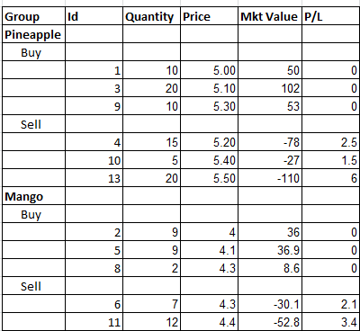

5

Use the output from the exercise 3 above and write a function to compute profit and loss for each sell transaction based on the First in First out for Pineapples.

P/L = Sell price * Sell Quantity – Buy price * Buy Quantity

Please show the output as a column on the grid/table displayed in exercise 4. (45 minutes to 1 hour).